**System Design Document**

**For**

**Optical (Laser) Communications Low-Cost Payload**

Team Members: Cameron Martinez, Dominic Steiner, Sean Huber, Jarrod Siglin, Matthew Simms, Dylan Koch

|  |  |
| --- | --- |
| Version/Author | Date |
| V1/Dominic Steiner, Cameron Martinez | 10/7/2022 |
| V2/All Members | 11/8/2022 |
| V3/Sean Huber, Cameron Martinez, Dylan Koch | 12/3/2022 |
| V4/ Sean Huber, Cameron Martinez, Matthew Simms | 03/10/2023 |

TABLE OF contents

1 INTRODUCTION 3

1.1 Purpose and Scope 3

1.2 Project Executive Summary 3

1.2.1 System Overview 3

1.2.2 Design Constraints 3

1.2.3 Future Contingencies 3

1.3 Document Organization 3

1.4 Project References 4

1.5 Glossary 4

2 SYSTEM ARCHITECTURE 4

2.1 System Hardware Architecture 4

2.2 System Software Architecture 4

2.3 Internal Communications Architecture 4

3 HUMAN-MACHINE INTERFACE 4

3.1 Inputs 5

3.2 Outputs 5

4 DETAILED DESIGN 5

4.1 Hardware Detailed Design 6

4.2 Software Detailed Design 6

4.3 Internal Communications Detailed Design 7

5 EXTERNAL INTERFACES 7

5.1 Interface Architecture 7

5.2 Interface Detailed Design 8

6 SYSTEM INTEGRITY CONTROLS 8

System Design Document

# INTRODUCTION

## Purpose and Scope

This System Design Document describes the system requirements, operating environment, system and subsystem architecture, files and database design, input formats, output layouts, human-machine interfaces, detailed design, processing logic, and external interfaces for a Low-Cost Optical Communications System.

## Project Executive Summary

NASA considers optical communications as the emerging technology of choice to enable high-data rate deep space wireless communications. Laser communication systems can achieve data rates beyond 100s of Gbps with payload size, weight, and power typically lower than traditional microwave systems. This project focuses on the design, fabrication, and demonstration of a low-cost optical communications system to be used on small-satellite payloads. It is created on a small scale - tabletop based - and is the concept intended to be utilized in future satellite optical communication.

Software challenges include coding onboard computers for sensor data acquisition and transmission. Hardware challenges include the design and fabrication of a laser diode-based transmitter, a sensor receiver, and a laser pointing mechanism. The system will use commercial off-the-shelf components (COTS) and a few custom-made PCBs to realize this system.

### System Overview

The product is a low-cost optical communication system, consisting of two sub-systems; a transmitter and a receiver. The goal is to have a video feed transmitted via laser and have the receiving device display and store the reception. It is created on a small scale - tabletop based - and is the concept intended to be utilized in future satellite optical communication. All systems will utilize COTS components, leading to lower costs and repeatability.

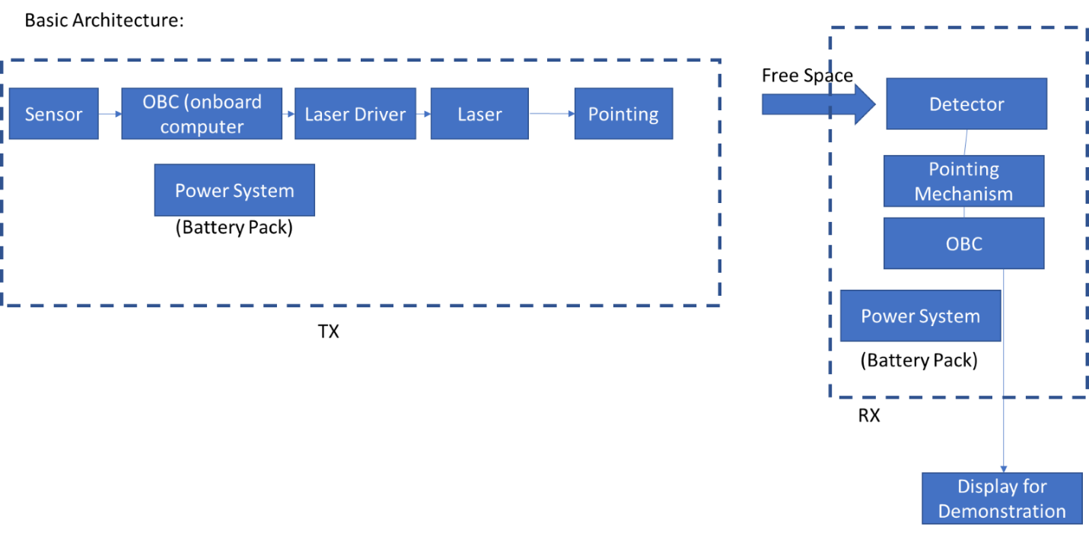Figure 1.2.1.1 Optical Communication Diagram, consisting of two sub-systems; transmitter (TX) on the left and receiver (RX) on the right.

This optical communication system is presented above in a broken-down, simplified style for ease of explanation. This system will utilize a camera sensor to pick up user inputs that will be serialized into data via an onboard computer (OBC). This data will be sent to the laser driver for transmission by the laser diode. The receiver will receive the data through a photodiode and decode the data in the OBC for display on a video monitor. The transmitting system (TX) will require a power system consisting of lithium-ion batteries to power all elements. The receiving system (RX) will utilize traditional AC outlet power for its components.

### Design Constraints

The biggest constraint of this system is the scale. It is designed to be a small proof-of- concept for a much larger design. With that in mind, the budget given is low relative to the necessary equipment that will accomplish the task in its entirety. The laser used is low power, thus limiting the information transmission range to less than 4 inches. To compensate for these design constraints, lenses can be used to extend the range of the laser. This creates a more practical system. The laser driver has a maximum bandwidth of 10kHz. Therefore, under UART signal standards the maximum achievable transmission speed is 960 Bytes/s. Another constraint is the budget. The system is designed to be low cost, using COTS components. The target is to keep all component costs below $2000 USD. The small size and budget allow for easier compatibility with satellites. Our design will be constrained to a portable power supply of 7.4V lithium-ion battery system with an amplifier pushing the voltage to 10V, along with a linear regulator for 5V and will fit within a 10in x 10in x 10in storage space. Having a lightweight and low-cost build will allow us to pitch this design to a larger market.

### Future Contingencies

A potential problem with long range implementation of a similar system is the spread of the laser versus the size of the receiver. This system has a laser with a high spread and dissipation rate while having a receiver the same width as the original signal. The ratio of the receiver size to transmission width should be large and at a minimum, proportional to the spread rate of whichever laser diode is utilized. The use of lenses to focus the transmission beam is one alternative plan.

There are some possible contingencies which would create problems. Currently, there are issues with the receiver. This has caused the group to return it for repairs. In the meantime, a new sensor is being ordered to possibly mitigate these problems. If the new sensor isn’t operable for the system’s needs, the old sensor must be used. The repairs may take weeks so other aspects of the project may need to be prioritized.

There is a similar concern for the laser diode. It is a crucial aspect of the system so if it were to fail, the system would be inoperable. We currently have another diode to function as a backup so that is our current solution, which should be enough.

There is a concern about the overall performance of the system with the bandwidth limitation. For this, there is an almost plug and play contingency laser driver to boost the bandwidth from 10kHz to 1MHz.

One other future contingency is the transmitter power distribution. The plan is to have the transmitter to be mobile, meaning that it will need an onboard power system. The initial design is to use rechargeable batteries for this, but it’s possible that this may not be able to support the power consumption of the system. In that case, a new design will need to be implemented. This may mean more batteries are needed, but it could also mean the sub-system needs to be redesigned.

## Document Organization

This section describes the organization of the Systems Design Document. First, the main parts of this project are introduced. Then, there is a detailed discussion of the overall system architecture. Next is a breakdown of the human-machine interface, followed by a detailed design of the system, including both hardware and software aspects. Succeeding this is an examination of the system’s external interfaces. Finally, there is an evaluation of the system integrity controls.

## Project References

Menlo Systems. (2021). *APD-Series High Sensitivity Avalanche Photodetector User Manual* [Photodiode receiver user’s manual]. <https://www.thorlabs.com/drawings/dbea16003904ede6-792C3D4D-E6CE-EC7F-4976A9400BD3E60B/APD310-Manual.pdf>.

ThorLabs. (2015). *1550 nm DFB Laser Diode, 5 mW* [Laser diode specifications sheet]. <https://www.thorlabs.com/drawings/dbea16003904ede6-792C3D4D-E6CE-EC7F-4976A9400BD3E60B/L1550P5DFB-SpecSheet.pdf>.

ThorLabs. (2018). *EK2000 OEM Laser Diode Driver Evaluation Kit User Guide* [Laser driver specifications and user's manual]. <https://www.thorlabs.com/drawings/dbea16003904ede6-792C3D4D-E6CE-EC7F-4976A9400BD3E60B/EK2000-Manual.pdf>.

ThorLabs. (2019). *PM400 Operating Manual* [Laser power and energy gauge user’s manual]. <https://www.thorlabs.com/drawings/dbea16003904ede6-792C3D4D-E6CE-EC7F-4976A9400BD3E60B/PM400-Manual.pdf>.

## Glossary

COTS - Commercial-Off-the-Shelf \

FCC – Federal Communications Commission

HDMI – High-Definition Multimedia Interface

ITU – International Telecommunications Union

MJPG – Motion JPEG

OBC - Onboard Computer

OOK – On-Off Keying

PCB - Printed Circuit Board

RX – Receiver

TX - Transmitter

UART - Universal Asynchronous Receiver-Transmitter

USD – United States Dollar

V –Volts

W – Watts

# SYSTEM ARCHITECTURE

## System Hardware Architecture (this needs work)

Our hardware starts with an Amplifier board which will push our 7.4V portable power source to 10V and a linear regulator for 5V to be utilized in the system. The amplifier board connects directly to the laser driver and the 5V regulator to the raspberry pi on the transmitter system. Using an optical video camera, we send still JPG data to the first Raspberry Pi via wire. In the future, the second Raspberry Pi drives to a motorized mount until the laser diode aligns with the receiver and can send information. Next, the Raspberry Pi converts the signal format to be suitable for infrared transmission and pushes that signal through the laser driver. The laser driver powers the diode in accordance with the signal sent from the camera. On the receiving end, our design starts with a receiver oriented in an unobstructed line from the laser diode. Then our receiver sends the infrared signal to a third Raspberry Pi along a wire. The Raspberry Pi converts the infrared signal back to MJPG and sends that data to the monitor by wire. Finally, the monitor will display the original video feed from the camera. All devices on the receiving end will be connected to a fixed power source such as a 12V outlet.

Raspberry Pi – Raspberry Pi Camera Module 2

ThorLabs – Optical laser diode

ThorLabs – Optical laser driver

ThorLabs – Photodiode receiver

Raspberry Pi (2x) – Onboard computer for transmitter and receiver

Amplifier Board - Will amplify received signal

Oscilloscope and other measurement devices for determining laser functionality

Motorized Diode Mount (Not yet designed)- receiver seeking motions

Raspberry Pi will also drive the motorized diode mount for Receiver seeking

## Figure 2.1.1 Overall System Hardware Architecture Top-View

## System Software Architecture

In our system, the first piece of hardware associated with our software design is the Raspberry Pi B 3+ that will control converting the MP4 video feed to a still JPG image stream. This stream is sent to the laser driver which will emit an infrared OOK to be transmitted by our laser diode. Python will be the language used to design the functions of every Raspberry Pi in our system. The Raspberry Pi 4 4GB will be used to convert the incoming IR signal back to an image feed which will be sent to a web server and the video displayed on our monitor.

## Internal Communications Architecture

Figure 2.3.1 Top-Level Architecture for Internal Communication

Components in each subsystem will be wired together to communicate. The camera uses Camera Serial Interface (CSI) to interact with the Raspberry Pi, which then uses Serial UART to communicate with the laser driver. The laser driver will act to modulate the signal and drive the laser diode, which transmits through free space. The sensor will receive the signal and send it to the Raspberry Pi with Serial UART. Finally, the Raspberry Pi will communicate the stream to a web server and physically via HDMI.

# HUMAN-MACHINE INTERFACE

The only anticipated human-machine interface is the display of the received transmission from the sensor. The plan is for the Raspberry Pi to communicate with a computer or laptop with an HDMI cable. This will then stream the video from the Raspberry Pi Camera. The user must only turn on the system and ensure that the monitor is connected to the system.

## Inputs

The input for the TX system is the sensor data from the camera. This data is converted into a bitstream to be sent to the receiver by using the laser driver and diode. The input for the RX system is the modulated laser output from the TX system. The only user input is the ability to turn on and off the TX system.

## Outputs

The TX system output is the modulated laser signal. This output is created by the laser driver, which will take the bitstream information from the OBC for modulation. The RX system output is the video display, created from the demodulation of the input signal.

# DETAILED DESIGN

## Hardware Detailed Design



Figure 4.1.1 Basic System Architecture Flow

* Sensor: A Raspberry Pi Camera module 2 for recording user inputs. This connects to the OBC on the transmission side using a SPI communication interface.
* Onboard Computer (OBC): Raspberry Pi 3 B+ with 40PIN Pre-Soldered GPIO Headers. This one will be on the transmission side for modulation of the camera data into the laser driver. The Raspberry Pi 4 4GB will be on the receiver side for demodulation into the display.
* Power System: This will be a custom subsystem composed of two 3.7V 3000 mAH batteries capable of powering all components, as well as supporting circuitry to modify voltages to acceptable values for these components.
* Laster Driver: The laser diode is presently driven by the EK2000 OEM Laser Diode Driver with a LD2000R mounted for control of the current and power output.
* Laser Diode: The current Laser diode is the ThorLabs L1550P5DFB 1550 nm DFB Laser Diode, 5 mW.
* Pointing: There have been no developments for the creation of the pointing system. Low priority.
* Free Space: This is the medium for wireless transmission.
* Detector: Our current Photodiode detector is the Menlo Systems PDA20C2.
* Display: We plan to use a computer monitor provided by the WiDE lab in the Micaplex.

## 4.1.1 Power Supply Detailed Design

This includes a Geekworm battery hat fed by two rechargeable lithium-ion batteries capable of supplying 7.4 V. The laser driver requires 9 V, which is achieved with an amplifier. The Raspberry Pi requires 5 V which is capable via the two batteries and a 5V regulator, and it is also able to power the camera. The receiver side is not designed to be portable so it can fit to any 120V outlet.

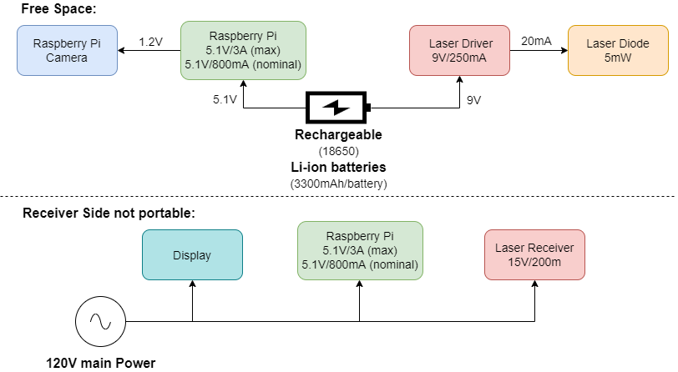

Figure 4.1.1.1 Overall Architecture for Power Supply

## Software Detailed Design

Two Raspberry Pi subsystems will be implemented, one as a transmitter and one as a receiver. The transmitter will generate the OOK based serial UART connection to the receiver, which will demodulate the signal into a physical and web display. This will be done in Python when dealing with the OpenCV libraries for the Raspberry Pi. The input will be provided from the Raspberry Pi camera through the CSI interface.

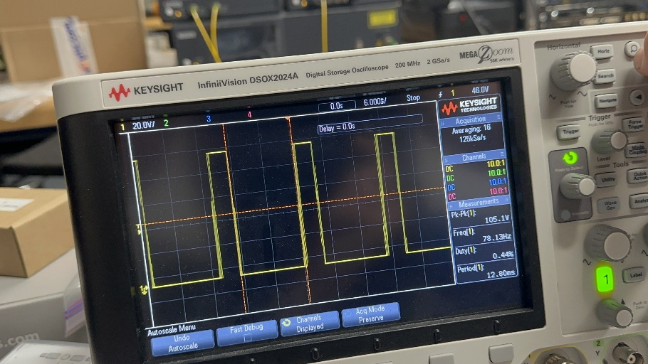

Figure 4.2.1 Image of Test Signal Optically Transmitted

## Internal Communications Detailed Design

The camera uses Camera Serial Interface (CSI) to interact with the Raspberry Pi, which then uses the integrated PL011 Serial UART to communicate with the laser driver. The laser driver will act to modulate the signal and drive the laser diode, which transmits through free space. The sensor will receive the signal to send to the PL011 Serial pin on the receiver to decode the image stream. Finally, the Raspberry Pi will display the image stream to a web page, a physical screen, and record a copy to storage.

Figure 4.3.1 Internal Communication Design Diagram

# EXTERNAL INTERFACES

## Interface Architecture

The object of this product design will incorporate no interaction with outside systems. As of now the only external interaction is between the laser driver and the fixed power supply in the lab. Since the power system is not yet designed, the system will be connected to external 120V for power. Also, an oscilloscope and signal generators will be used for design and testing.

## Interface Detailed Design

This is an independent system that will not be interacting with outside systems. However, communication, in general, is heavily regulated by the Federal Communications Commission (FCC) and International Telecommunications Union (ITU). Optical communication is a newer field, but with more research done, it's possible these regulations may affect the system. The FCC and ITU currently restrict and delegate specific frequency bands to different organizations and uses. This system uses the 1550 nm wavelength which is unregulated and acceptable to be used on a small-scale independent system such as this one. In the future, NASA and other agencies will have to use frequencies not only capable of long-range transmission, but also ones that are in the allotted frequency range.

# SYSTEM INTEGRITY CONTROLS

This is a low hazard and low budget project. The laser output is always kept below 5 mW and it is a fixed system in a relatively secure environment. There are currently no concerns for its safety or the safety of those interacting with the components. Any video feed we use will not be inappropriate or proprietary. All components will be turned off when not in use to preserve their life and prevent things such as overheating or power surge. When the laser is in operation, no person will attempt to directly move or obstruct components. This is to prevent unnecessary wear on the system and keep people from playing with the project.